Ganesh sesha sai Akhil . Koutarapu
AP21110010931
CSE-O
FRONTEND for CASE STUDY :

1.Train:
CREATE TABLE Train (
Train_ID INT PRIMARY KEY,
Train_Name VARCHAR(100),
Departure_Station VARCHAR(100),
Arrival_Station VARCHAR(100),
Departure_Time TIME,
Arrival_Time TIME,
Total_Seats INT,
Available_Seats INT
);
Frontend output in html :
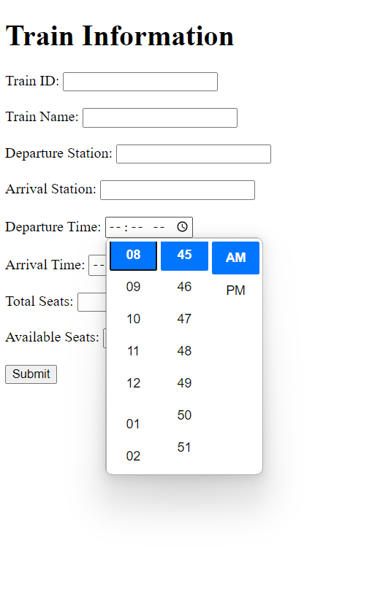
2.Passenger:
CREATE TABLE Passenger (
Passenger_ID INT PRIMARY KEY,
Name VARCHAR(100),
Contact_Number VARCHAR(20),
Address TEXT
);
Frontend output in html:
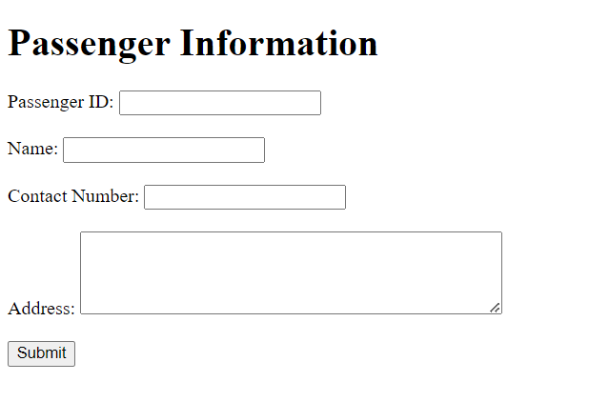
3.Reservation:
CREATE TABLE Reservation (
Reservation_ID INT PRIMARY KEY,
Passenger_ID INT,
Train_ID INT,
Seat_Number INT,
Date DATE,
FOREIGN KEY (Passenger_ID) REFERENCES Passenger(Passenger_ID),
FOREIGN KEY (Train_ID) REFERENCES Train(Train_ID)
);
Frontend output in html:
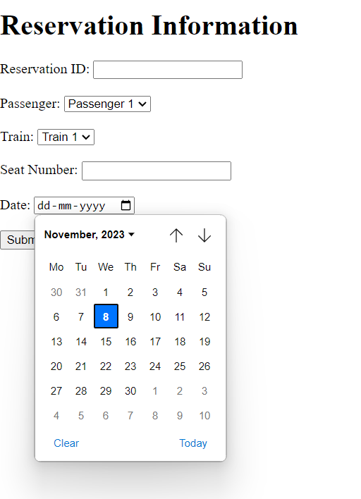
4.Ticket:
CREATE TABLE Ticket (
Ticket_ID INT PRIMARY KEY,
Reservation_ID INT,
Fare DECIMAL(10, 2),
Payment_Status VARCHAR(20),
FOREIGN KEY (Reservation_ID) REFERENCES Reservation(Reservation_ID)
);
Frontend outout in html:
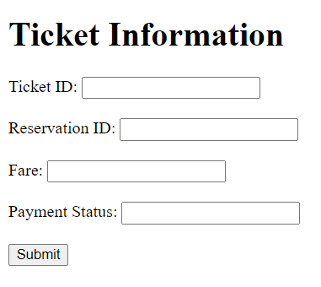
5.Station:
CREATE TABLE Station (
Station_ID INT PRIMARY KEY,
Station_Name VARCHAR(100),
Location VARCHAR(100)
);
Frontend output in html :
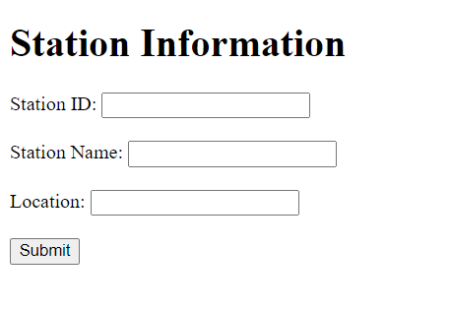
6.Employee:
CREATE TABLE Employee (
Employee_ID INT PRIMARY KEY,
Name VARCHAR(100),
Position VARCHAR(100),
Contact_Number VARCHAR(20)
);
Frontend Output in html:
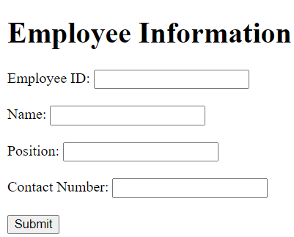
Frontend for all Tables:
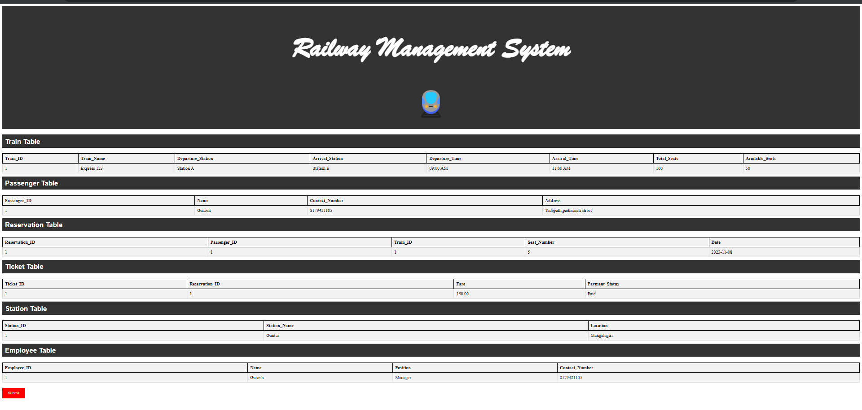
Code:
<!DOCTYPE html>
<html>
<head>
<style>
/* Add CSS styles for your tables */
table {
border-collapse: collapse;
width: 100%;
margin-top: 20px;
border: 2px solid black;
background-color: #f2f2f2;
}

th, td {
border: 1px solid #dddddd;
text-align: left;
padding: 8px;
}

th {
background-color: #f2f2f2;
border: 2px solid black;
}

tr:nth-child(even) {
background-color: #f2f2f2;
}

/* Style the heading for each table */
h2 {
background-color: #333;
color: white;
padding: 10px;
margin: 10px 0;
font-family: Arial, sans-serif;
}

/* Style the submit button with red color */
input[type="submit"] {
background-color: red;
color: white;
padding: 10px 20px;
border: none;
cursor: pointer;
margin-top: 20px;
}

/* Style for the main heading */
.main-heading {
text-align: center;
background-color: #333;
color: white;
padding: 20px;
margin-bottom: 20px;
font-family: "Brush Script MT", cursive;
font-size: 50px;
}

/* Style for the train symbol */
.train-symbol {
text-align: center;
font-size: 100px;
}
</style>
</head>
<body>

<!-- Main Heading -->
<div class="main-heading">
<h1>Railway Management System</h1>
<div class="train-symbol">🚆</div>
</div>

<!-- Train Table -->
<h2>Train Table</h2>
<table>
<tr>
<th>Train_ID</th>
<th>Train_Name</th>
<th>Departure_Station</th>
<th>Arrival_Station</th>
<th>Departure_Time</th>
<th>Arrival_Time</th>
<th>Total_Seats</th>
<th>Available_Seats</th>
</tr>
<tr>
<td>1</td>
<td>Express 123</td>
<td>Station A</td>
<td>Station B</td>
<td>09:00 AM</td>
<td>11:00 AM</td>
<td>100</td>
<td>50</td>
</tr>
<!-- Add more rows here if needed -->
</table>

<!-- Passenger Table -->
<h2>Passenger Table</h2>
<table>
<tr>
<th>Passenger_ID</th>
<th>Name</th>
<th>Contact_Number</th>
<th>Address</th>
</tr>
<tr>
<td>1</td>
<td>Ganesh</td>
<td>8179421105</td>
<td>Tadepalli,padmasali street</td>
</tr>
<!-- Add more rows here if needed -->
</table>

<!-- Reservation Table -->
<h2>Reservation Table</h2>
<table>
<tr>
<th>Reservation_ID</th>
<th>Passenger_ID</th>
<th>Train_ID</th>
<th>Seat_Number</th>
<th>Date</th>
</tr>
<tr>
<td>1</td>
<td>1</td>
<td>1</td>
<td>5</td>
<td>2023-11-08</td>
</tr>
<!-- Add more rows here if needed -->
</table>

<!-- Ticket Table -->
<h2>Ticket Table</h2>
<table>
<tr>
<th>Ticket_ID</th>
<th>Reservation_ID</th>
<th>Fare</th>
<th>Payment_Status</th>
</tr>
<tr>
<td>1</td>
<td>1</td>
<td>150.00</td>
<td>Paid</td>
</tr>
<!-- Add more rows here if needed -->
</table>

<!-- Station Table -->
<h2>Station Table</h2>
<table>
<tr>
<th>Station_ID</th>
<th>Station_Name</th>
<th>Location</th>
</tr>
<tr>
<td>1</td>
<td>Guntur</td>
<td>Mangalagiri</td>
</tr>
<!-- Add more rows here if needed -->
</table>

<!-- Employee Table -->
<h2>Employee Table</h2>
<table>
<tr>
<th>Employee_ID</th>
<th>Name</th>
<th>Position</th>
<th>Contact_Number</th>
</tr>
<tr>
<td>1</td>
<td>Ganesh</td>
<td>Manager</td>
<td>8179421105</td>
</tr>
<!-- Add more rows here if needed -->
</table>

<!-- Add a submit button with red color -->
<input type="submit" value="Submit">

</body>
</html>

